Hadoop and MapReduce Architecture for a Cancer Prediction Big Data Project

Executive Summary
Hadoop’s core architecture is still best understood as two major layers: HDFS for distributed storage and YARN for cluster resource management. In HDFS, a NameNode manages namespace metadata and block placement, while DataNodes store the actual file blocks. In YARN, a global ResourceManager allocates resources, NodeManagers run on each worker, and each application gets an ApplicationMaster that negotiates containers and supervises execution. Legacy Hadoop MapReduce used a single JobTracker with per-node TaskTrackers, but modern Hadoop runs MapReduce on top of YARN using an ApplicationMaster and containers. [1]
For your project, the most important architectural decision is not “use every Hadoop component,” but rather separate operational data management from analytical processing. Your C# WinForms application needs low-friction CRUD-like access to patient, dataset, job, and prediction records; that aligns much better with MongoDB Atlas and its flexible document model, schema validation options, high availability features, alerting, and access-control features. By contrast, HDFS is optimized for high-throughput access to large datasets and batch-style workflows, which makes it a better fit for raw data landing zones, curated training snapshots, and optional large-scale archives than for live application-facing records. [2]
Given that cluster size and budget are unspecified, the most robust recommendation is a Spark-first, MongoDB-first design: use PySpark for ETL, feature engineering, and model training; use MongoDB Atlas as the operational store and model/prediction registry; and treat HDFS as optional unless your course or deployment explicitly requires a Hadoop cluster. Components such as Hive, Oozie, HBase, Flume, Pig, Sqoop, ZooKeeper, and the YARN Timeline Service should be considered optional extensions, not mandatory first-iteration requirements. Spark is especially well aligned with your stack because the official PySpark docs emphasize its unified execution model, in-memory computing, DataFrame-oriented optimization, and scalable ML library support. [3]

Hadoop and MapReduce Architecture
At the storage layer, HDFS uses a master/slave design. The NameNode maintains the file system namespace and block mapping, while DataNodes serve reads/writes and execute block creation, deletion, and replication under NameNode instruction. HDFS stores files as blocks, replicates those blocks for fault tolerance, and is designed for large datasets, fault tolerance, and high-throughput access, with an explicit bias toward batch processing rather than interactive low-latency access. That distinction matters directly for your project because it explains why HDFS is excellent for raw CSV/Parquet training corpora but a poor primary store for live patient forms in a WinForms front end. [4]
In legacy MapReduce on Hadoop 1.x, the compute and storage nodes commonly lived on the same machines so the framework could push work close to the data. The cluster had a single JobTracker that scheduled tasks and monitored them, plus a TaskTracker on each worker node to execute tasks. This is the classic architecture many course diagrams still teach. It remains useful conceptually, but it is not the modern control-plane architecture you would build around for a new project. [5]
In modern Hadoop, resource management moved into YARN. The ResourceManager arbitrates cluster resources, NodeManagers run on each machine and manage containers, and each application gets its own ApplicationMaster. The ResourceManager contains a Scheduler and an ApplicationsManager; the Scheduler allocates containers, while the ApplicationMaster asks for containers and tracks task progress. Hadoop’s own YARN docs explicitly note that MapReduce on Hadoop 2.x preserves compatibility with the older API while shifting execution into this newer RM/AM/container model. [6]
For availability, modern HDFS supports Active/Standby NameNodes. In HA mode, the Standby tails edits from JournalNodes, applies those edits, and can take over quickly if the Active fails. The docs also make an important architectural point: in an HA cluster, the Standby NameNode performs checkpointing, so a Secondary NameNode should not be run alongside HA NameNodes. YARN likewise supports Active/Standby ResourceManagers, and its HA design uses a ZooKeeper-based elector embedded in the RMs to select the active leader. [7]
The YARN Timeline Service v2 is not a compute engine; it is a monitoring/history subsystem. Its architecture separates collectors from readers, and the official docs state that it uses Apache HBase as its primary backing store because HBase scales for read/write workloads while keeping reasonable latency. This is useful as a conceptual pattern for job history and observability, but for your project it is usually simpler to store pipeline runs, metrics, and audit events in MongoDB unless you are explicitly deploying a full YARN cluster and want native Hadoop history plumbing. [8]
The following diagram is a synthesized, project-oriented view of the official HDFS, YARN, MapReduce, and HA documentation. It is meant to show where the canonical Hadoop control plane sits, how MapReduce fits into YARN today, and where the legacy JobTracker/TaskTracker model belongs historically. [9]
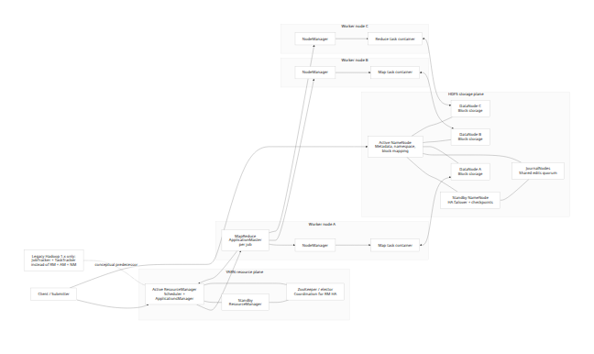

Core Ecosystem Components
Not every component in the Hadoop ecosystem should appear in the first version of your cancer prediction system. The table below distinguishes between the official role of each component and its practical relevance to your project’s current stack. The core pattern is straightforward: HDFS/YARN/MapReduce define the cluster substrate, while Hive, HBase, Pig, Sqoop, Flume, Oozie, ZooKeeper, and Timeline Service are specialized ecosystem services. [10]
Component | Official role | Relevance to your project | Recommended stance
HDFS | Distributed storage for large datasets, with block replication, high throughput, and batch-oriented access. [11] | Good for raw files, feature snapshots, training corpora, and reproducible batch inputs. | Optional but useful if you need a true Hadoop data lake or course-required cluster.
NameNode | Holds namespace metadata and maps blocks to DataNodes. [12] | Relevant only if you deploy HDFS. | Only if HDFS exists.
DataNode | Stores blocks and handles read/write/replication under NameNode control. [12] | Relevant only if you deploy HDFS. | Only if HDFS exists.
Secondary NameNode | Legacy checkpointing helper; in HA clusters, Standby NameNodes do checkpointing instead, and a Secondary NameNode should not be run. [13] | Mostly educational/historical unless you intentionally build non-HA HDFS. | Not needed for your first implementation.
Standby NameNode + JournalNodes | HDFS HA: Active/Standby NameNodes with JournalNodes for shared edits and fast failover. [14] | Useful only if you operate a real HDFS cluster and need availability. | Future-scale option.
YARN ResourceManager | Global cluster resource arbiter; contains Scheduler and ApplicationsManager. [15] | Relevant if you run Spark or MapReduce on Hadoop cluster nodes. | Optional; not required for local PySpark or small deployments.
NodeManager | Per-node YARN agent; manages containers and reports resource usage. [16] | Relevant only with YARN cluster deployment. | Optional.
ApplicationMaster + containers | Per-application control in YARN; negotiates resources and supervises execution. [17] | Important conceptually for modern MapReduce/Spark-on-YARN. | Architectural knowledge required; implementation optional.
MapReduce JobTracker/TaskTracker | Legacy Hadoop 1.x job scheduler/executor architecture. [5] | Useful in diagrams, exams, and historical explanation. | Teach/diagram only, unless the course explicitly asks for MRv1 concepts.
YARN Timeline Server | Stores and serves generic and framework-specific application history; v2 separates collectors/readers and uses HBase backend. [18] | Could inspire a job-history screen, but overkill for your first version. | Replace with MongoDB job/audit collections initially.
Hive | SQL data warehouse layer on Hadoop; can query data in HDFS/HBase and execute via Tez or MapReduce. [19] | Useful if you want BI-style SQL over curated data. | Nice-to-have, not core to your current stack.
HBase | Distributed NoSQL store on Hadoop/HDFS for random realtime read/write over very large tables. [20] | Strong when low-latency massive-scale wide-column access is required. | Not recommended for this project unless scale grows far beyond Atlas’s intended use in your app.
Pig | High-level language and infrastructure that compiles workflows into MapReduce programs. [21] | Educational and useful for legacy Hadoop ETL patterns. | Not recommended when you already use Python and PySpark.
Sqoop | Bulk transfer tool between Hadoop and structured datastores; official docs now note the project is retired. [22] | Relevant mainly for RDBMS↔Hadoop ingestion. | Avoid unless you must demo classic ecosystem breadth.
Flume | Distributed system for collecting, aggregating, and moving large event/log data volumes. [23] | Useful if you later ingest logs, telemetry, or streaming events. | Not needed for current CSV/patient-dataset workflows.
Oozie | Workflow scheduler for Hadoop jobs; supports DAGs and time/data-triggered coordinators for MapReduce, Pig, Hive, Sqoop, and more. [24] | Useful for production Hadoop scheduling. | Optional later; Python orchestration is simpler now.
ZooKeeper | Coordination, naming, synchronization, leader election, and related distributed-system primitives. [25] | Relevant indirectly for HA Hadoop services. | Infrastructure concern, not first-version app module.

Mapping the Ecosystem to Your Project
Your project naturally divides into two planes. The first is the application plane, where users manage datasets, patient records, models, predictions, and jobs from a C# WinForms interface. The second is the analytics plane, where Python and PySpark execute batch ingestion, profiling, feature extraction, training, and scoring. Those two planes should not share the same storage strategy. HDFS is explicitly tuned for large, high-throughput, batch-oriented file access, whereas MongoDB is explicitly designed around a flexible document model, transactions, high availability, and application-serving workflows. [26]
That means the cleanest mapping is this: MongoDB Atlas becomes the project’s operational system of record, holding patient documents, dataset metadata, ingestion jobs, quality metrics, feature-set references, model runs, predictions, audit events, and UI-facing summaries. PySpark becomes the default processing engine because the official docs emphasize Spark’s unified analytics engine, in-memory execution features, scalable ML library, and DataFrame-oriented optimization path. HDFS becomes optional tiered storage for raw data landing, immutable snapshots, and reproducible training inputs when cluster-based scaling is actually required. [27]
Within that mapping, several ecosystem components become either optional or mostly illustrative. Hive is helpful if you want SQL analysis over curated files; Oozie is useful only when you have enough batch jobs to justify native Hadoop orchestration; Flume matters if the project evolves toward streaming logs or telemetry; HBase matters only if you need very large, low-latency random-access tables on top of HDFS; and Pig and Sqoop are poor fits for a modern Python/PySpark/MongoDB stack. ZooKeeper matters only when you operationalize HA coordination for Hadoop services rather than when you build application features. [28]
So, if this project is being graded partly on Hadoop ecosystem understanding, the right answer is not “install everything.” The stronger answer is: use the ecosystem selectively and justify each component by workload type. For your current stack, that usually means PySpark + MongoDB Atlas first, with HDFS/Hive/Oozie added only if the project scope, grading rubric, or data volume makes them worthwhile. That position is consistent with the official descriptions of HDFS, Spark, Hive, and MongoDB Atlas. [29]

Proposed Project Modules and WinForms UI
The module design below is a project architecture inference built on the official capabilities of HDFS, Spark, and MongoDB Atlas: use HDFS for raw immutable batch data when needed, use PySpark for distributed ETL and ML, and use MongoDB Atlas for flexible, application-facing documents plus operational metadata. Atlas security, schema validation, indexing guidance, and alerting also make it suitable for app operations and governance screens. [30]
Proposed module | Purpose | Inputs and outputs | Data flow | Storage recommendation | Processing recommendation | WinForms UI interactions
Dataset Intake and Catalog | Register uploaded CSV/Excel sources, tag source type, schema version, and ingestion status. | Input: files, source metadata, uploader, timestamps. Output: dataset record, raw file pointer, ingestion job ID. | User uploads file → Python intake validates columns → raw artifact stored → dataset record created → job queued. | MongoDB Atlas: dataset catalog, schema, ingestion job metadata. HDFS optional: raw landed files and immutable snapshots. | Python for lightweight validation; PySpark when file size or profiling complexity grows. | Upload screen, dataset list, schema preview, “Start Ingestion” button, status column, error panel.
Patient Record and Case Management | Maintain patient-centered views used by the app, not just training rows. | Input: patient demographics, clinical features, labels/stages, notes, file attachments or references. Output: patient documents and case history. | UI form → validation → MongoDB patient document update → downstream jobs can materialize training views. | MongoDB Atlas primary. HDFS is unnecessary for live CRUD-like case access. | Direct Python service layer or data-access helpers; Spark only for bulk exports and cohort builds. | Patient search, create/edit form, table/grid view, filter by diagnosis/status, history tab.
Data Quality and Standardization | Detect nulls, type drift, outliers, duplicates, label imbalance, and invalid codes before training. | Input: dataset snapshot. Output: quality report, cleaned/standardized version, issue list. | Intake module calls PySpark profiling → report written → curated dataset marked ready or rejected. | MongoDB Atlas: quality summaries and issue logs. HDFS optional: cleaned batch snapshots and Parquet outputs. | PySpark preferred for scalable profiling and standardization across repeated runs. | Quality dashboard, rule violations table, “Approve for Training” action, downloadable diagnostics.
Feature Store and Training Set Builder | Produce reproducible feature vectors and target labels from raw or curated records. | Input: curated dataset, feature config, target definition. Output: training matrix metadata, feature-set version, split manifest. | Curated snapshot → Spark feature job → feature-set metadata stored → training/test split recorded. | MongoDB Atlas: feature-set definitions, manifests, version metadata. HDFS optional: large feature matrices. | PySpark for transformation, joins, encoding, normalization, and reproducible splits. | Feature configuration screen, transformation presets, split ratio controls, version history viewer.
Model Training and Evaluation | Train baseline and candidate models, compare metrics, and store reproducible experiment runs. | Input: feature-set version, algorithm config, hyperparameters. Output: model run, metrics, artifact location, confusion matrix, ROC summary. | WinForms launches training job → Python submits Spark pipeline → metrics saved → best model flagged. | MongoDB Atlas: model registry, metrics, hyperparameters, artifact metadata. HDFS optional: large intermediate training artifacts. | PySpark / Spark MLlib for scalable training; plain Python acceptable for small baselines. | “Train Model” dialog, experiment list, metric comparison grid, charts, best-model badge.
Prediction Serving and Results Review | Score new patient cases or batch cohorts and present interpretable outputs to users. | Input: patient form or batch file, chosen model version. Output: risk score, class prediction, timestamped prediction record. | UI submits case → Python loads current model metadata → scoring runs → MongoDB prediction document saved → UI refreshes result. | MongoDB Atlas primary for prediction history and retrieval. HDFS optional only for large batch score exports. | Python scoring service for interactive use; PySpark for batch scoring against many cases. | Single-case prediction form, batch scoring wizard, result panel, risk threshold highlight, history tab.
Operations, Audit, and Governance | Track job runs, model lineage, user actions, alert states, and release versions. | Input: all module events. Output: audit log, job history, lineage view, admin status. | Every major action emits metadata → stored centrally → surfaced in admin dashboards. | MongoDB Atlas primary for audit documents and admin metadata. | Lightweight Python logging; Spark only when summarizing large historical job data. | Job monitor, audit timeline, model lineage view, connection/settings page, admin alerts page.
A practical GitHub layout that fits this module design is a mono-repo with folders such as winforms-app/, python-services/, spark-jobs/, schemas/, docs/architecture/, and tests/. GitHub then becomes the cross-cutting control point for code versioning, documentation, issue tracking, release tags, and model/feature schema evolution. That is a design recommendation rather than a Hadoop requirement, but it aligns well with the modular split above.

Architecture Diagrams and Data Flows
The next diagram shows the recommended project integration architecture. It deliberately keeps MongoDB Atlas as the operational backbone and PySpark as the compute backbone, while leaving HDFS as an optional analytical landing layer instead of forcing it into every user-facing path. That recommendation follows directly from the official positioning of HDFS, Spark, and MongoDB Atlas. [31]
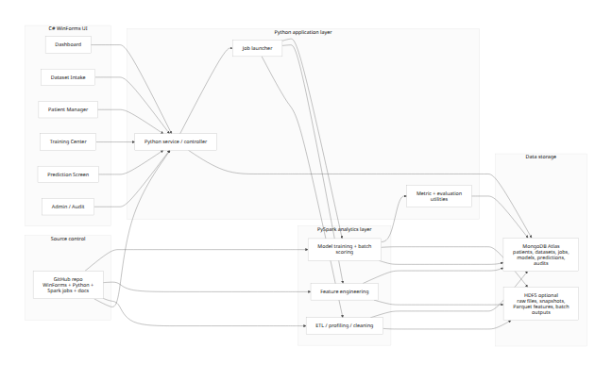
A good way to think about operational flow is: WinForms initiates, Python coordinates, PySpark computes, MongoDB serves, and HDFS optionally stores reproducible large batch artifacts. That preserves a simple user experience while keeping the analytical path scalable. [32]
The following sequence illustrates a training run triggered from the desktop application.
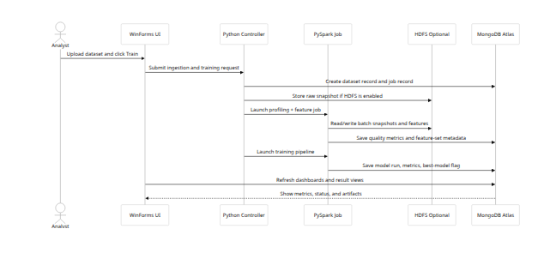
The next flowchart shows a single-case prediction path, which should stay lightweight and MongoDB-centric rather than routing the user through a heavy Hadoop batch pipeline.
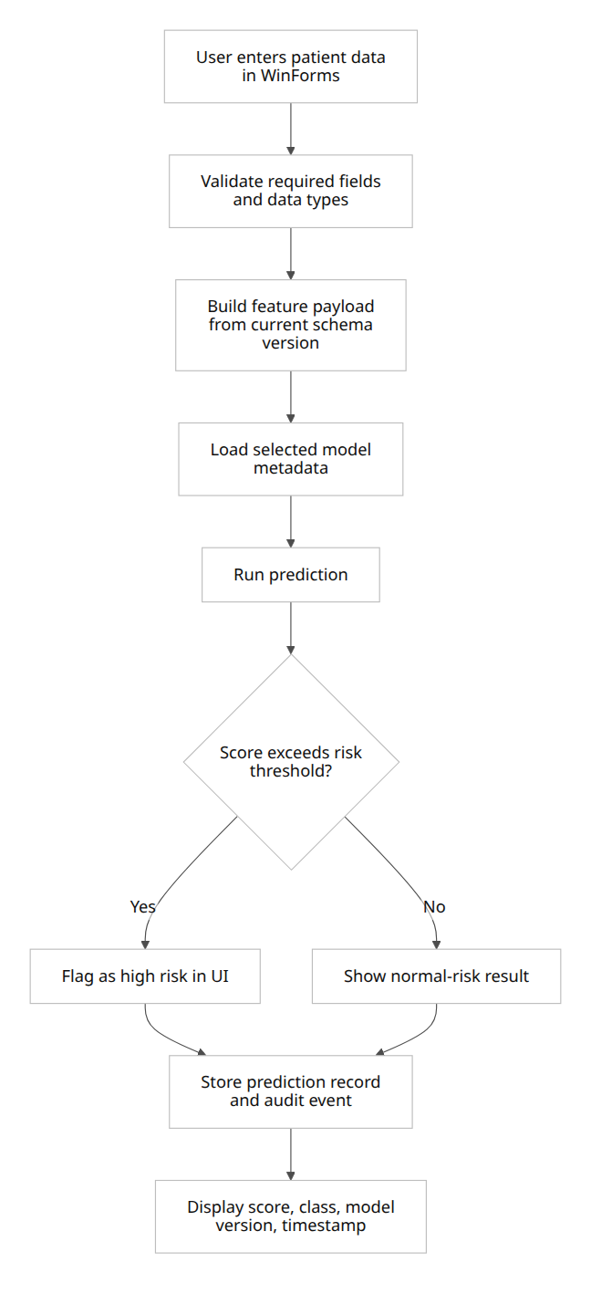
For MongoDB, a pragmatic data model is to keep app-facing entities in separate collections with explicit references between them. MongoDB officially supports flexible schema evolution and several relationship patterns, while schema validation can be added where you need tighter controls. [33]
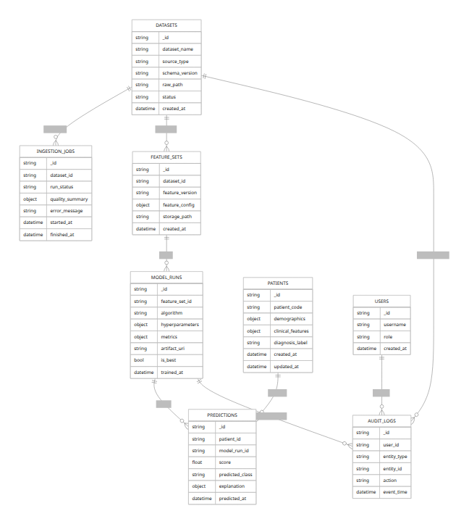

Decision Tables and Recommended Choices
The first strategic choice is where each class of data belongs.
Criterion | HDFS | MongoDB Atlas | Recommended choice for this project
Best-fit data shape | Large files split into replicated blocks; optimized for distributed file access. [34] | Flexible document model; supports schema evolution and application-oriented records. [35] | Use HDFS for raw and batch artifacts, MongoDB for operational records.
Access pattern | High-throughput, large-scale, batch-oriented; not aimed at low-latency interactive use. [11] | Built for application access, querying, indexing, transactions, and operational workflows. [36] | Keep the WinForms UI on MongoDB, not HDFS.
Update behavior | Write-once except append/truncate; ideal for immutable snapshots. [37] | Mutable documents with validation options and richer app semantics. [38] | Store training snapshots in HDFS if needed; keep patient/prediction entities in MongoDB.
Operations and governance | Hadoop-native HA and replication patterns. [14] | Atlas offers managed deployment, alerts, access lists, and operational tooling. [39] | For an application team and desktop UI, Atlas is operationally simpler.
Strongest role in your system | Raw landing zone, reproducible training data, large batch exports. | System of record for datasets, patients, jobs, model registry, predictions, audit history. | Hybrid architecture, but with MongoDB as the default primary store.
The second major choice is how to process data.
Criterion | Classic MapReduce | Spark and PySpark | Recommended choice for this project
Execution model | Map and Reduce stages coordinated by legacy JobTracker/TaskTracker or modern YARN-backed MR execution. [40] | Unified engine for data engineering, SQL, streaming, and machine learning. [41] | Prefer Spark/PySpark.
Reuse across multiple steps | Good for stage-based batch jobs, but less natural for iterative analytics. | In-memory capabilities and reusable distributed abstractions improve iterative workflows. [42] | Prefer Spark, especially for feature engineering and repeated evaluation.
ML support | No comparable first-class modern ML stack in the official MapReduce docs. | Official PySpark docs include MLlib and recommend higher-level APIs. [43] | Use PySpark for training and batch scoring.
Developer fit with your stack | More natural in Java/Hadoop-native workflows. | Native fit with Python and your existing PySpark code path. [41] | Use PySpark.
Best role in your project | Educational demonstration of Hadoop internals or course-required exercises. | Main ETL, cleaning, feature engineering, model training, and bulk prediction engine. | Spark should be the default processing engine.
The resulting recommendation is clear: MongoDB Atlas + PySpark should be the project default, while HDFS should be introduced only for raw-zone storage or cluster-based reproducibility, and classic MapReduce should be reserved for conceptual understanding, assignments, or very specific batch demos. That recommendation is more rigorous than “use Hadoop everywhere,” because it aligns each tool with the workload it was actually designed to handle. [44]

Authoritative Sources
The following sources were the highest-value references for this report. All are official project or vendor documentation except the original Google MapReduce paper, which is included because it is the canonical architectural origin of the model.
- Apache Hadoop HDFS Architecture Guide — official storage architecture, NameNode/DataNode roles, blocks, replication, and throughput assumptions. [45]
- Apache Hadoop YARN — official YARN architecture, ResourceManager, NodeManager, ApplicationMaster, Scheduler, and containers. [6]
- Apache Hadoop MapReduce Tutorial — authoritative legacy JobTracker/TaskTracker description and data-local execution model. [5]
- HDFS High Availability with QJM / NFS — official HA treatment of Active/Standby NameNodes, JournalNodes, and the role of Standby vs Secondary NameNode. [46]
- Apache Hadoop ResourceManager HA — official RM HA architecture and ZooKeeper-based failover discussion. [47]
- YARN Timeline Service v2 — official collectors/readers architecture and HBase-backed history subsystem. [18]
- Apache Spark site, PySpark overview, and RDD guide — official Spark capabilities, in-memory execution, MLlib, and distributed data abstractions. [48]
- Apache Hive introduction/docs — official SQL-on-Hadoop positioning, storage/query options, and execution engines. [49]
- Apache HBase home and architecture — official role of HBase as a distributed, scalable big-data store for random realtime access on Hadoop/HDFS. [20]
- Apache Pig — official description of Pig Latin and Pig’s compilation into MapReduce workflows. [21]
- Apache Sqoop docs — official bulk-transfer purpose and retirement status. [50]
- Apache Flume User Guide — official event/log collection and aggregation role. [23]
- Apache Oozie — official DAG/workflow scheduler role and supported Hadoop job types. [24]
- Apache ZooKeeper — official coordination, synchronization, naming, and leader-election role. [25]
- MongoDB Atlas and MongoDB docs — official Atlas operations, flexible schema, schema validation, alerts, and IP access controls. [51]
- Google MapReduce paper — canonical origin of the MapReduce programming model. [52]

[1] [4] [9] [10] [11] [12] [26] [29] [30] [31] [34] [37] [44] [45] Apache Hadoop 3.3.5 – HDFS Architecture
https://hadoop.apache.org/docs/stable/hadoop-project-dist/hadoop-hdfs/HdfsDesign.html
[2] [27] [36] What is MongoDB? - Database Manual
https://www.mongodb.com/docs/manual/?utm_source=chatgpt.com
[3] [32] [42] [43] PySpark Overview — PySpark 4.1.2 documentation
https://spark.apache.org/docs/latest/api/python/index.html
[5] [40] MapReduce Tutorial
https://hadoop.apache.org/docs/r1.2.1/mapred_tutorial.html
[6] [15] [16] [17] Apache Hadoop 3.3.5 – Apache Hadoop YARN
https://hadoop.apache.org/docs/stable/hadoop-yarn/hadoop-yarn-site/YARN.html
[7] [14] Apache Hadoop 3.3.5 – HDFS High Availability Using the Quorum Journal Manager
https://hadoop.apache.org/docs/stable/hadoop-project-dist/hadoop-hdfs/HDFSHighAvailabilityWithQJM.html
[8] [18] Apache Hadoop 3.3.5 – The YARN Timeline Service v.2
https://hadoop.apache.org/docs/stable/hadoop-yarn/hadoop-yarn-site/TimelineServiceV2.html
[13] Apache Hadoop 3.3.5 – HDFS Commands Guide
https://hadoop.apache.org/docs/stable/hadoop-project-dist/hadoop-hdfs/HDFSCommands.html?utm_source=chatgpt.com
[19] [28] Documentation
https://hive.apache.org/docs/latest/
[20] Apache HBase – Apache HBase™ Home
https://hbase.apache.org/1.1/
[21] Welcome to Apache Pig!
https://pig.apache.org/
[22] Apache Sqoop documentation — Apache Sqoop documentation
https://sqoop.apache.org/docs/1.99.3/index.html
[23] Flume 1.11.0 User Guide — Apache Flume
https://flume.apache.org/FlumeUserGuide.html
[24] Oozie - Apache Oozie Workflow Scheduler for Hadoop
https://oozie.apache.org/
[25] ZooKeeper: Because Coordinating Distributed Systems is a Zoo
https://zookeeper.apache.org/doc/r3.9.5/index.html
[33] [35] Data Modeling in MongoDB - Database Manual
https://www.mongodb.com/docs/manual/data-modeling/?utm_source=chatgpt.com
[38] Schema Validation - Database Manual - MongoDB Docs
https://www.mongodb.com/docs/manual/core/schema-validation/?utm_source=chatgpt.com
[39] [51] MongoDB Atlas: Multi-Cloud Database Service - Atlas - MongoDB Docs
https://www.mongodb.com/docs/atlas/
[41] [48] Apache Spark™ - Unified Engine for large-scale data analytics
https://spark.apache.org/
[46] Apache Hadoop 3.3.5 – HDFS High Availability
https://hadoop.apache.org/docs/stable/hadoop-project-dist/hadoop-hdfs/HDFSHighAvailabilityWithNFS.html
[47] Apache Hadoop 3.3.5 – ResourceManager High Availability
https://hadoop.apache.org/docs/stable/hadoop-yarn/hadoop-yarn-site/ResourceManagerHA.html
[49] Introduction to Apache Hive
https://hive.apache.org/docs/latest/introduction-to-apache-hive/
[50] Sqoop -
https://sqoop.apache.org/
[52] https://research.google/pubs/mapreduce-simplified-data-processing-on-large-clusters/
https://research.google/pubs/mapreduce-simplified-data-processing-on-large-clusters/

